Market (WPU) Work flow

1. Update “PARKnSHOP_20211207.docx”
2. Go to location “I:\Pzone\Public\CPI_01&02\weekly_update_system\program\Excel VBA working”

Open file “step1_WPU_program_main.xlsm”

1. Create folder which is today, for example “2021/12/14”

|  |
| --- |
| 1. Change to today :2021/12/14 2. For long week : bi-weekly (Y)   For short week: bi-weekly (N) |

1. Download data in CAPI

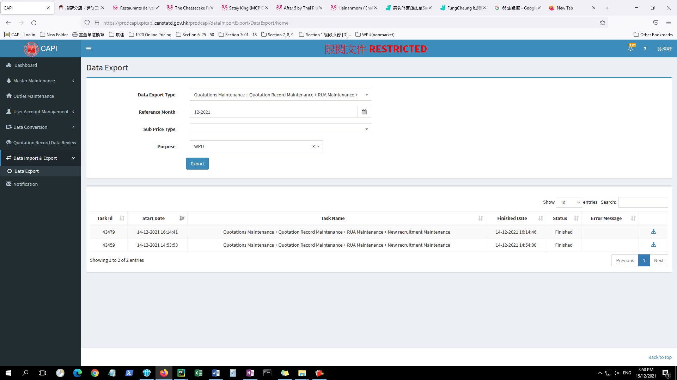

File: “Quotations Maintenance + Quotation Record Maintenance + RUA Maintenance + New recruitment Maintenance.xlsx”

1. Change the column of “Quotations Maintenance + Quotation Record Maintenance + RUA Maintenance + New recruitment Maintenance.xlsx”
   1. “Collection Date” change to today
   2. “Quotation Status” change “Draft”, “blank” to “submit”
   3. “Outlet Type English Name” change “Market / Street stall” to “Market/Street stall”
2. Move the file “Quotations Maintenance + Quotation Record Maintenance + RUA Maintenance + New recruitment Maintenance.xlsx” to location “I:\Pzone\Public\CPI_01&02\weekly_update_system\program\Excel VBA working”.
3. In “step1_WPU_program_main.xlsm”

|  |
| --- |
| 1. Push “open field record”, then “supermarket” |

1. Open “I:\Pzone\Public\CPI_01&02\weekly_update_system\program\Excel VBA working”

File: “step3_sup_working.xlsm”

|  |
| --- |
| 1. Check the price and remark, make sure is corrent 2. Push “Update data from field record”      1. For short week, go to the sheet “sup1”, “sup2”   For long week, go to the sheet “sup1”, “sup2”, “sup1_bi”, “sup_2_bi”  Check the data is updated’ “Quan”, “Unit”, “Original”, Converted”, “curent remart &reason”  *華盛頓紅蘋果(4016, 88裝)*   1. Click “save as PDF”   For long week, it geneated 6 files  “主要食品每週零售價格(SUP1)_1_20211214.pdf”  “主要食品每週零售價格(SUP1)_2_20211214.pdf’  “主要食品每週零售價格(SUP2)_1_20211214.pdf”  “主要食品每週零售價格(SUP2)_2_20211214.pdf’  “主要食品每週零售價格_1_20211214.pdf”  “主要食品每週零售價格_2_20211214.pdf”  For short week, it geneated 3 files  “主要食品每週零售價格_1_20211207.pdf”  “主要食品每週零售價格(SUP2)_1_20211207.pdf”  “主要食品每週零售價格(SUP1)_1_20211207.pdf |

1. Print and hand the files to SO

|  |
| --- |
| Short week  主要食品每週零售價格_1_20211207.pdf  主要食品每週零售價格(SUP2)_1_20211207.pdf  主要食品每週零售價格(SUP1)_1_20211207.pdf  PARKnSHOP_20211207.docx  Long week  主要食品每週零售價格(SUP1)_1_20211214.pdf  主要食品每週零售價格(SUP1)_2_20211214.pdf  主要食品每週零售價格(SUP2)_1_20211214.pdf  主要食品每週零售價格(SUP2)_2_20211214.pdf  主要食品每週零售價格_1_20211214.pdf  主要食品每週零售價格_2_20211214.pdf  PARKnSHOP_20211207.docx |

1. Wait the other sa/soii finish the “market"
2. Print and hand to SO

Explain the column “vs PW” in “主要食品每週零售價格_1”, if >0.0%

Confirm raw data is true

今個星期d數無變, 除非impute, 缺貨

1. After confirm by SO
2. Open “step1_WPU_program_main.xlsm”

|  |
| --- |
| In step 5,     1. Click “Update path and date for final report” 2. Click “Update data for final report”   If something need to update manually, update the file located in “I:\Pzone\Public\CPI_01&02\weekly_update_system\temp_output”  File “Weekly Price Update_market_20211214.xls”   1. Click “Generate report”   File “Weekly Price Update_market_20211207.xlsx” will be generated   1. Click Protect report and make a copy for sending out” 2. Create checksum file |

1. Finally, print and hand “Weekly Price Update_market_20211207.xls”

To sum up, the file of market WPU should be finished

|  |
| --- |
| Short week:  主要食品每週零售價格_1_20211207.pdf  主要食品每週零售價格(SUP2)_1_20211207.pdf  主要食品每週零售價格(SUP1)_1_20211207.pdf  Weekly Price Update_market_20211207.xlsx  PARKnSHOP_20211207.docx  Long week:  主要食品每週零售價格(SUP1)_1_20211214.pdf  主要食品每週零售價格(SUP1)_2_20211214.pdf  主要食品每週零售價格(SUP2)_1_20211214.pdf  主要食品每週零售價格(SUP2)_2_20211214.pdf  主要食品每週零售價格_1_20211214.pdf  主要食品每週零售價格_2_20211214.pdf  Weekly Price Update_market_20211214.xlsx  PARKnSHOP_20211214.docx |

Remark Update

缺貨, first 4 times -> 缺貨impute(1), impute(2) , impute(3) , impute(4)

缺貨, After 4 times-> 缺貨已impute四次

Check: product spec, same?

缺貨

Price change